ASSIGNMENT NO.6: Data Manipulation and Table Management

Student Name | Aayan Sayyed | Roll Number | 20963
Batch | SY. BSc Data Science | Topic | WB(Assignment-6)

Questions:
Q1) Create a MySQL database named CollegeDB and create two tables: Course and Student.
Query: CREATE TABLE Course (
CourseID INT PRIMARY KEY,
CourseName VARCHAR(50) NOT NULL,
Fees DECIMAL(10,2) NOT NULL
);

CREATE TABLE Student (
StudentID INT PRIMARY KEY,
StudentName VARCHAR(50) NOT NULL,
Age INT,
City VARCHAR(30),
CourseID INT,
FOREIGN KEY (CourseID) REFERENCES Course(CourseID)
);
Output:
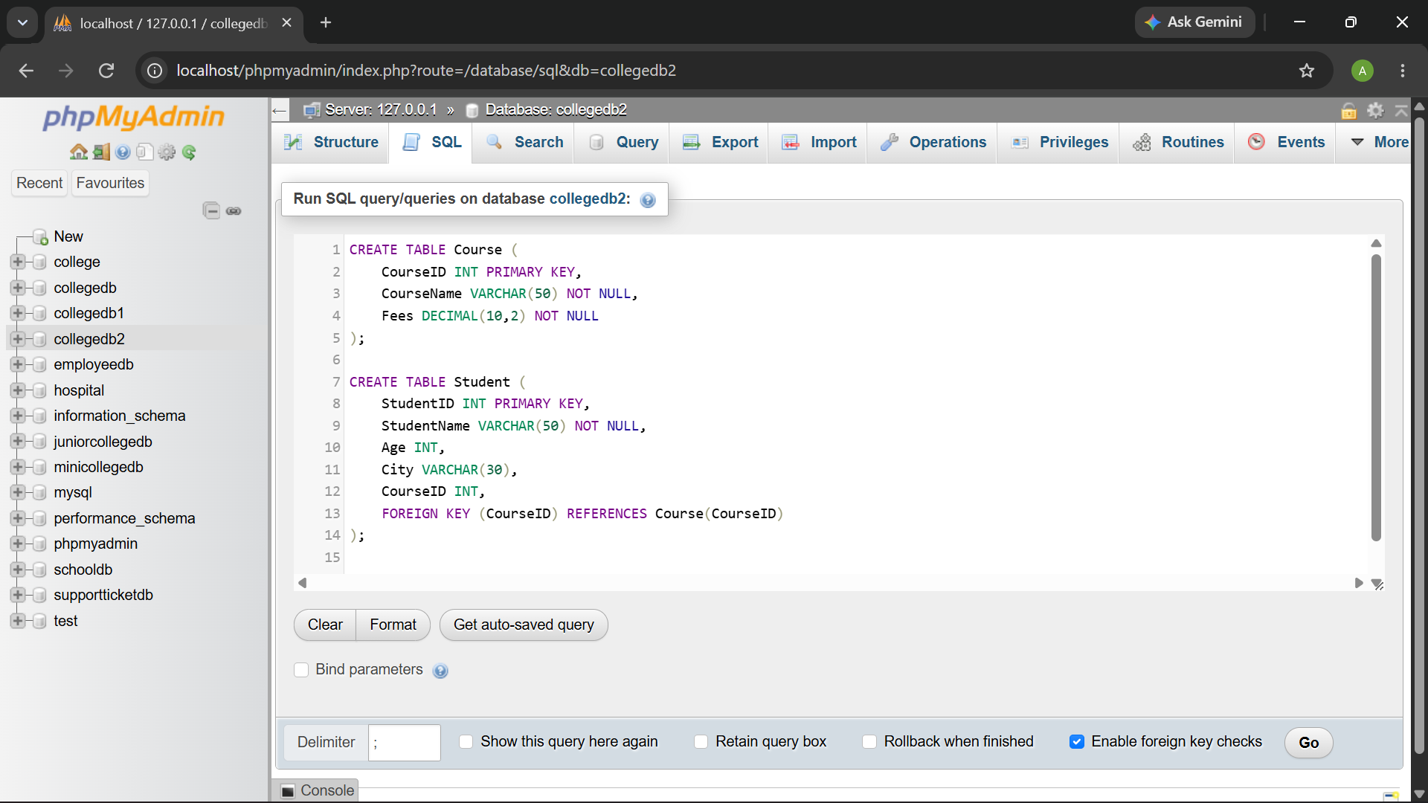
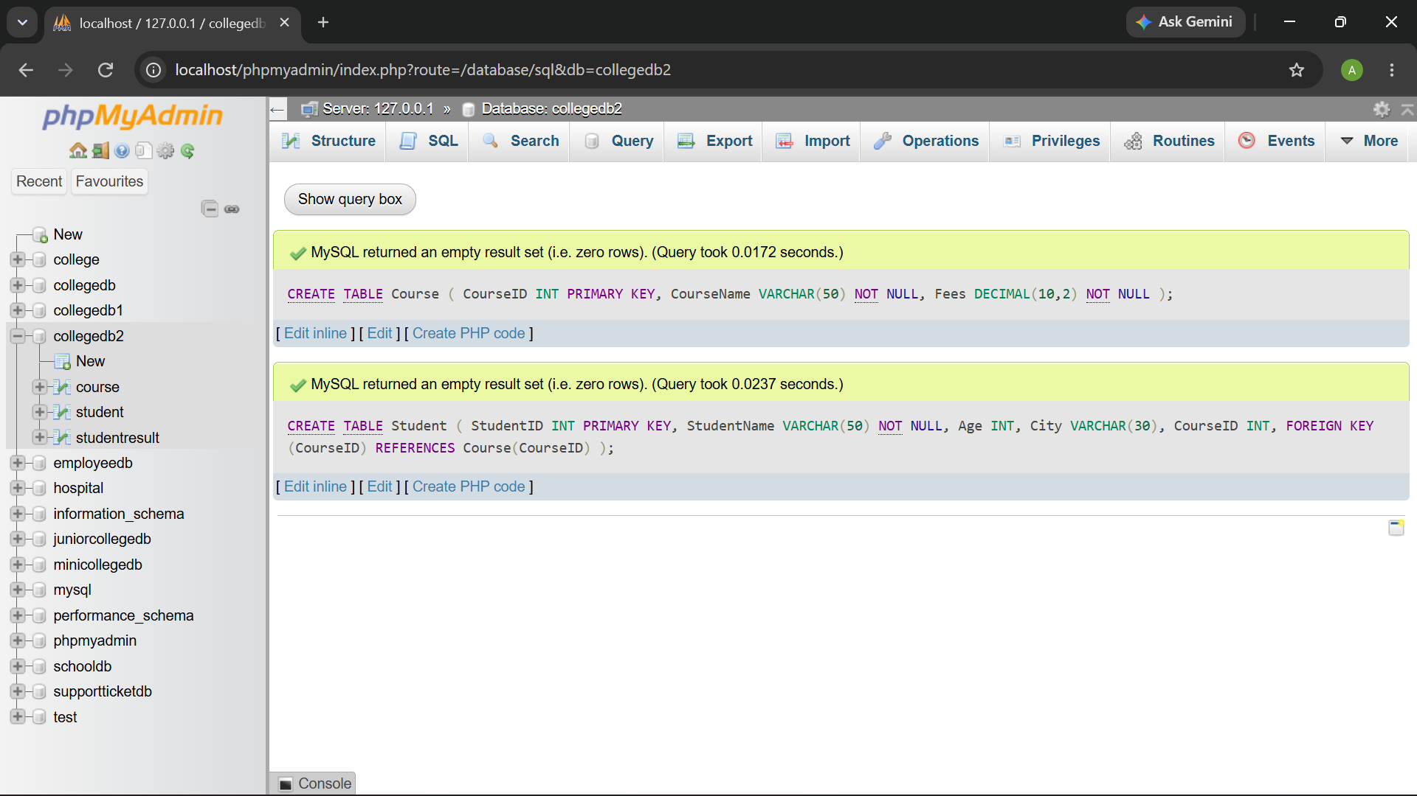
Q2) Insert at least 4 records into the Course table and 6 records into the Student table.
Query: INSERT INTO Course (CourseID, CourseName, Fees) VALUES
(101, 'BSc IT', 45000.00),
(102, 'BCA', 40000.00),
(103, 'BSc CS', 42000.00),
(104, 'Data Science', 55000.00);

INSERT INTO Student (StudentID, StudentName, Age, City, CourseID) VALUES
(1, 'Rahul Sharma', 20, 'Mumbai', 101),
(2, 'Priya Patil', 19, 'Pune', 102),
(3, 'Aman Verma', 21, 'Nashik', 103),
(4, 'Sneha Joshi', 20, 'Mumbai', 101),
(5, 'Karan Mehta', 22, 'Thane', 102),
(6, 'Neha Shah', 19, 'Pune', 104);
Output:
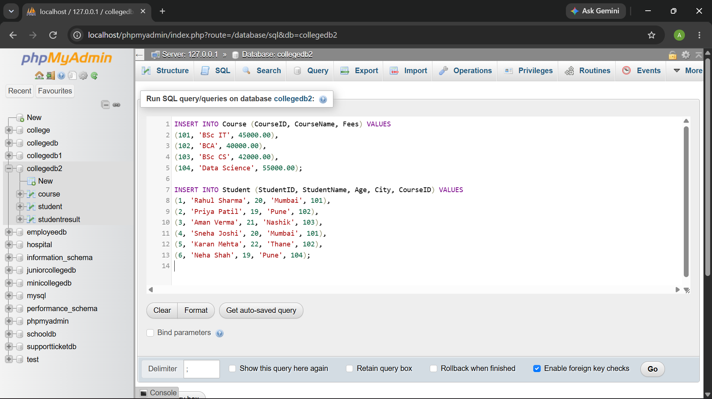
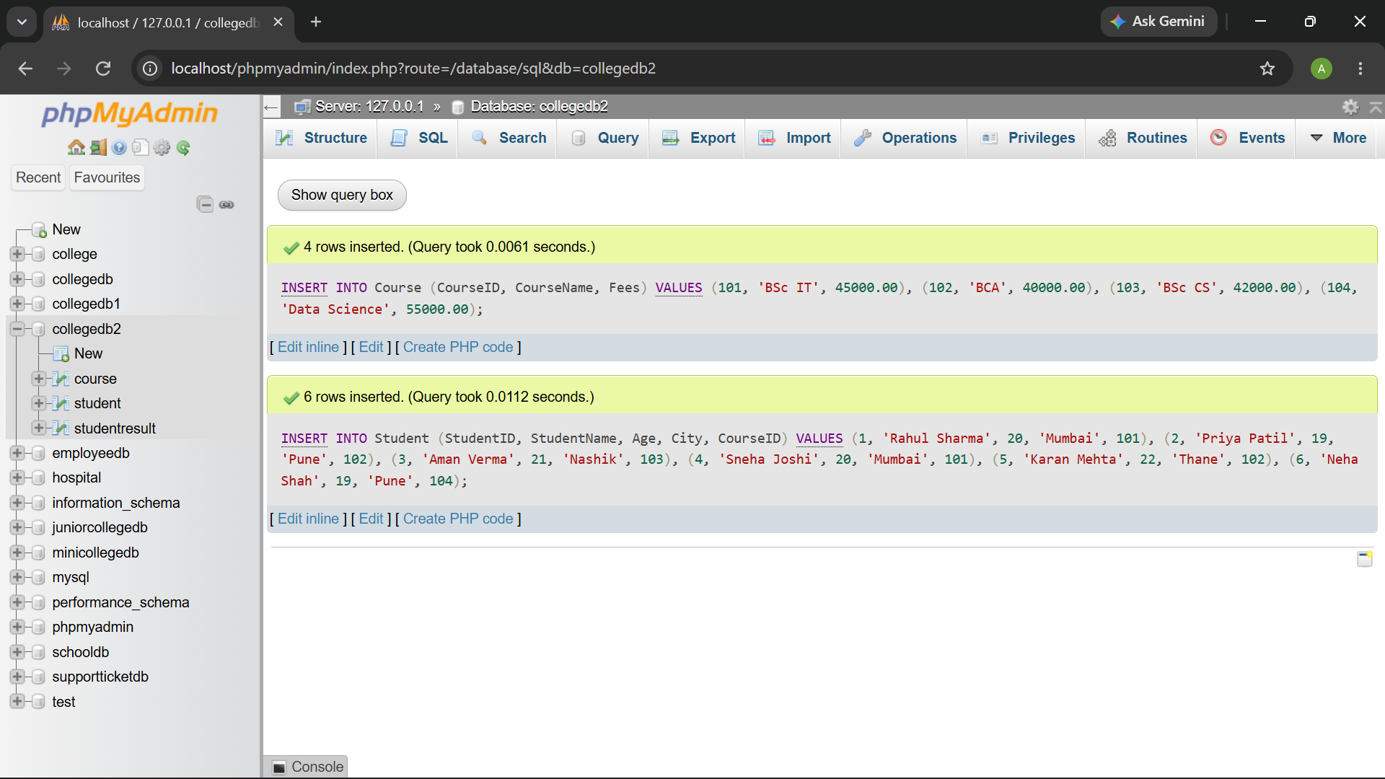

Q3) Write a MySQL query to insert one new student record into the Student table.
Query: INSERT INTO Student (StudentID, StudentName, Age, City, CourseID)
VALUES (7, 'Divya More', 20, 'Mumbai', 104);
Output:
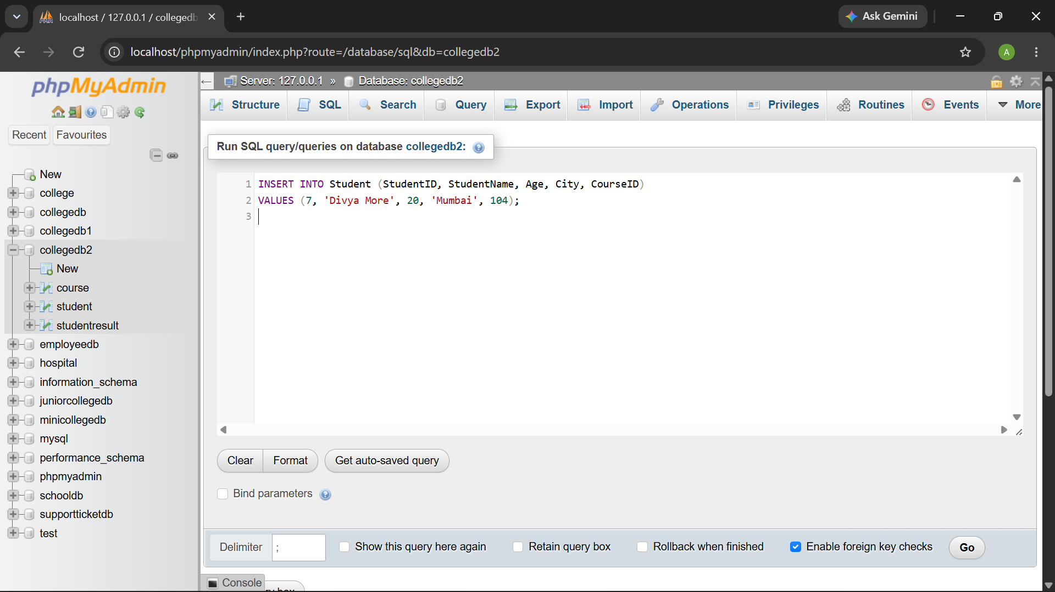
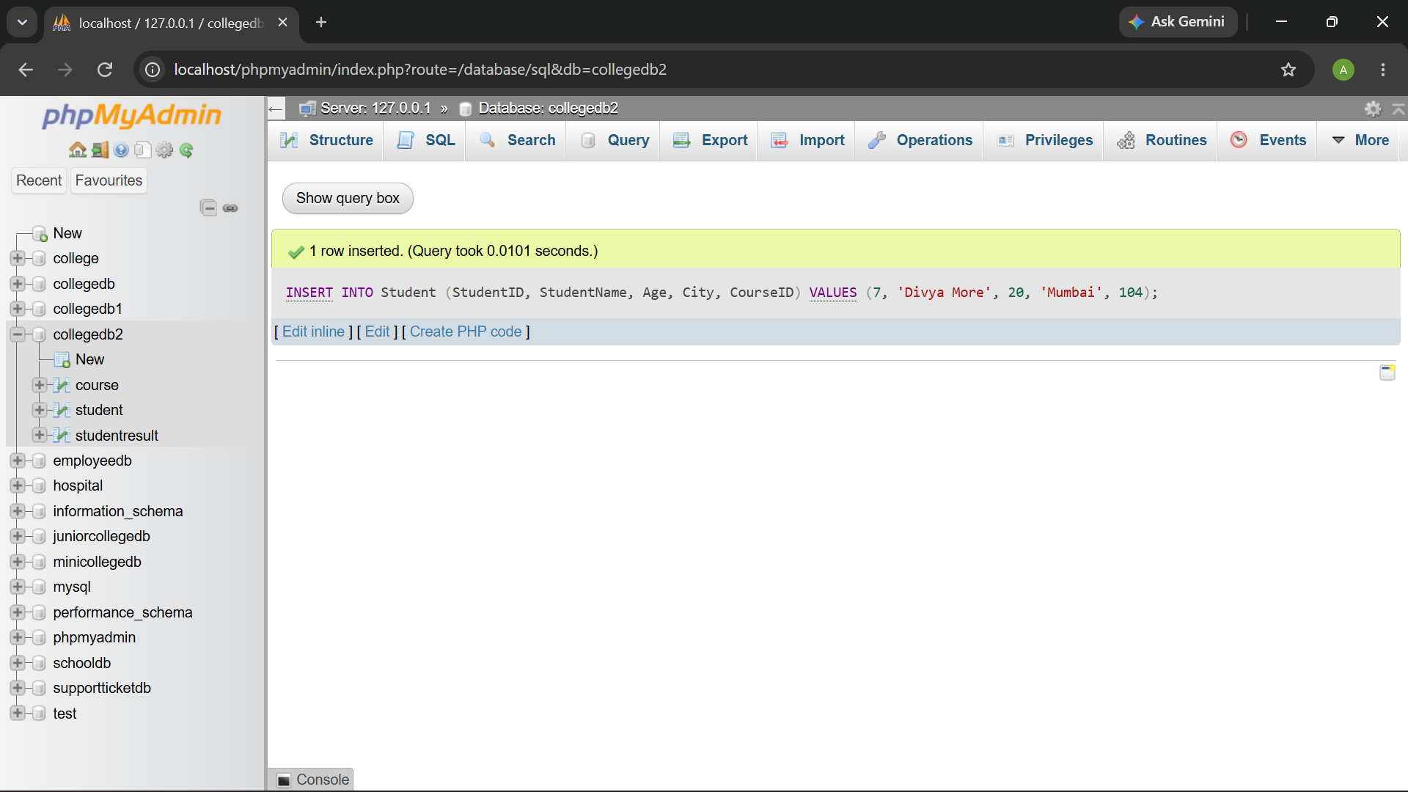
Q4) Write a MySQL query to update the city of a student using StudentID.
Query: UPDATE Student SET City = 'Mumbai' WHERE StudentID = 2;
Output:
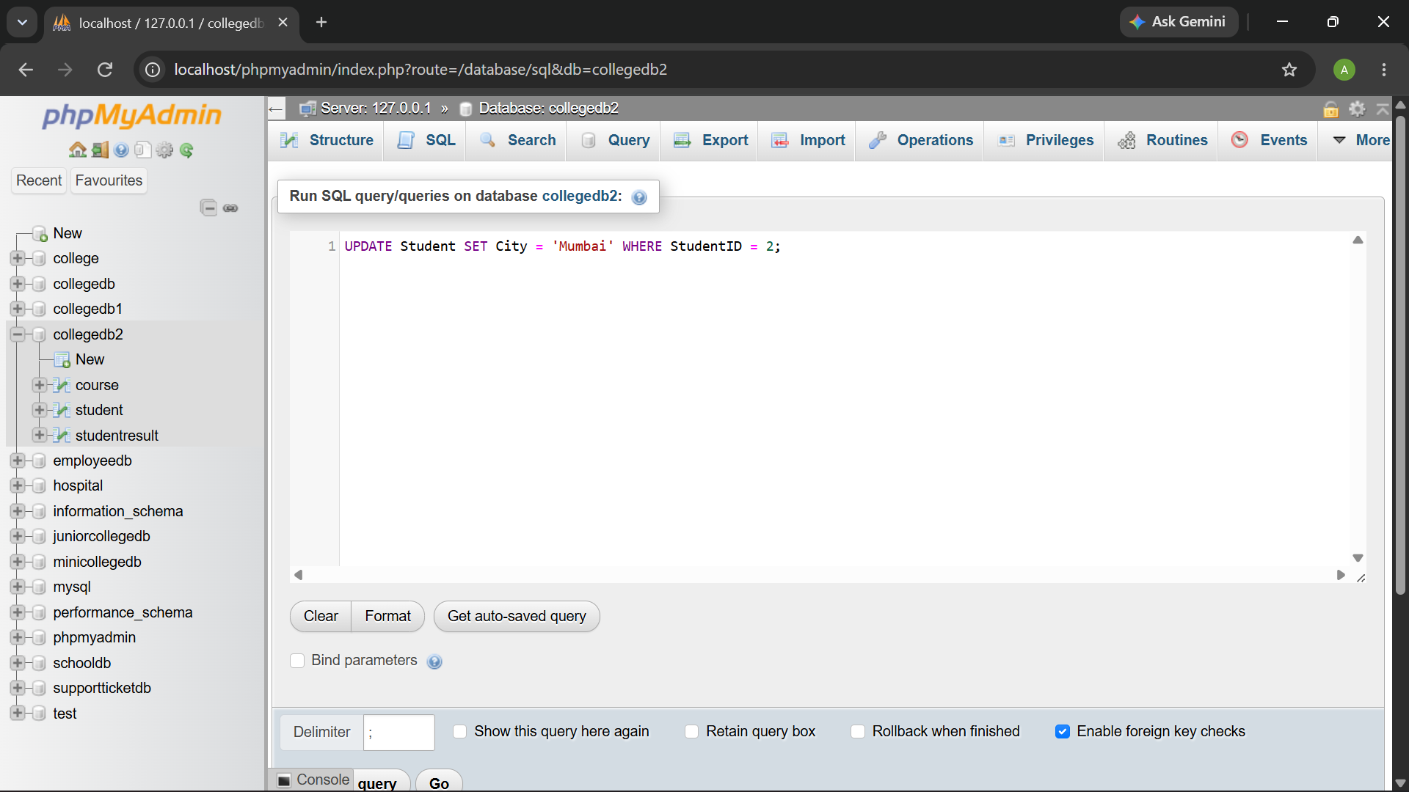
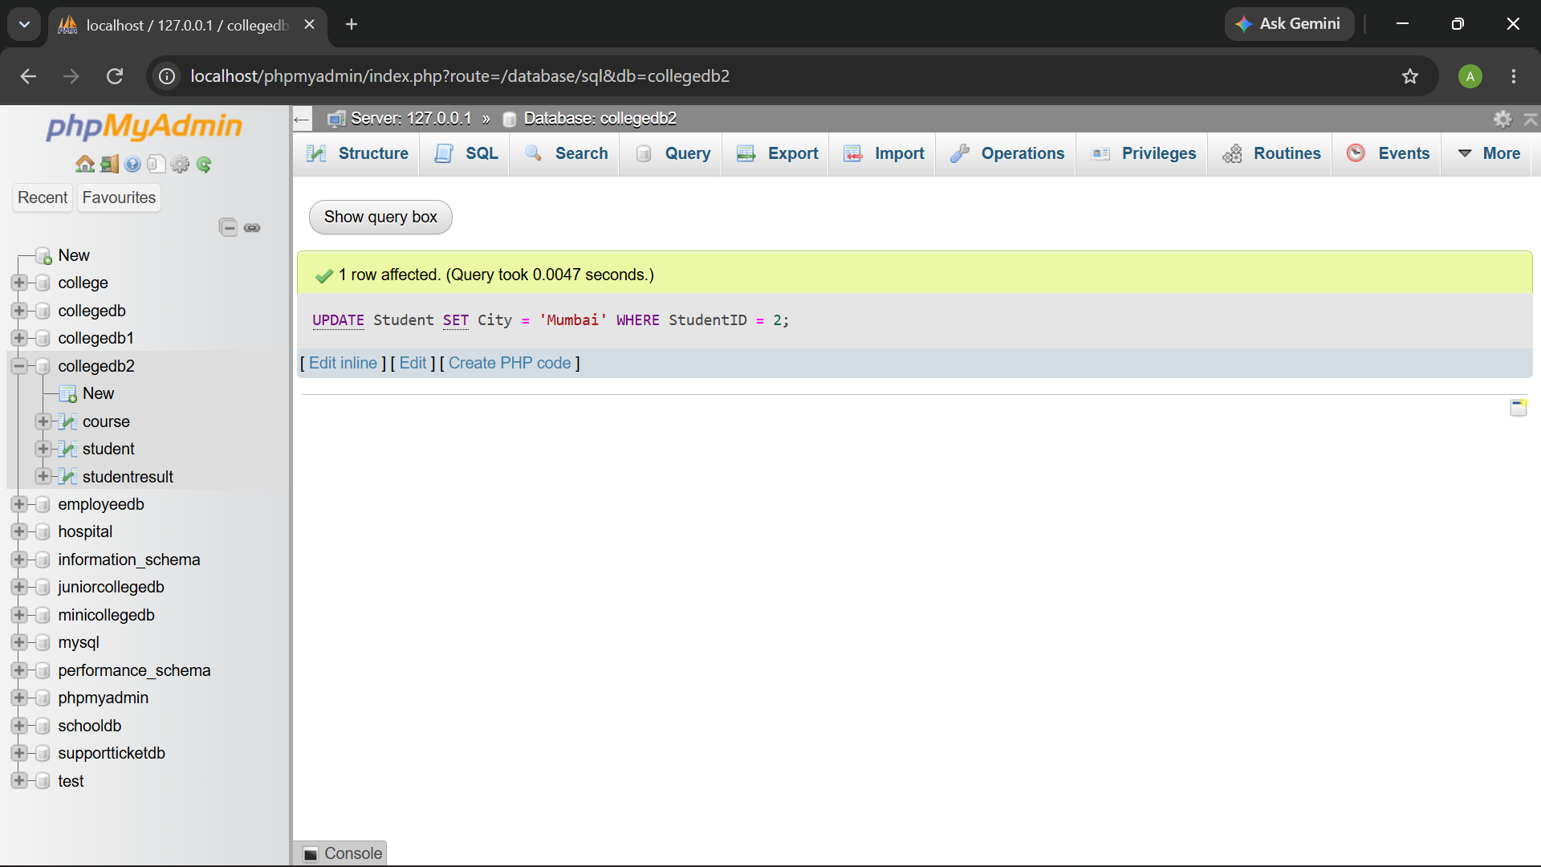

Q5) Write a MySQL query to update the fees of a course using CourseID.
Query: UPDATE Course SET Fees = 47000.00 WHERE CourseID = 101;
Output:
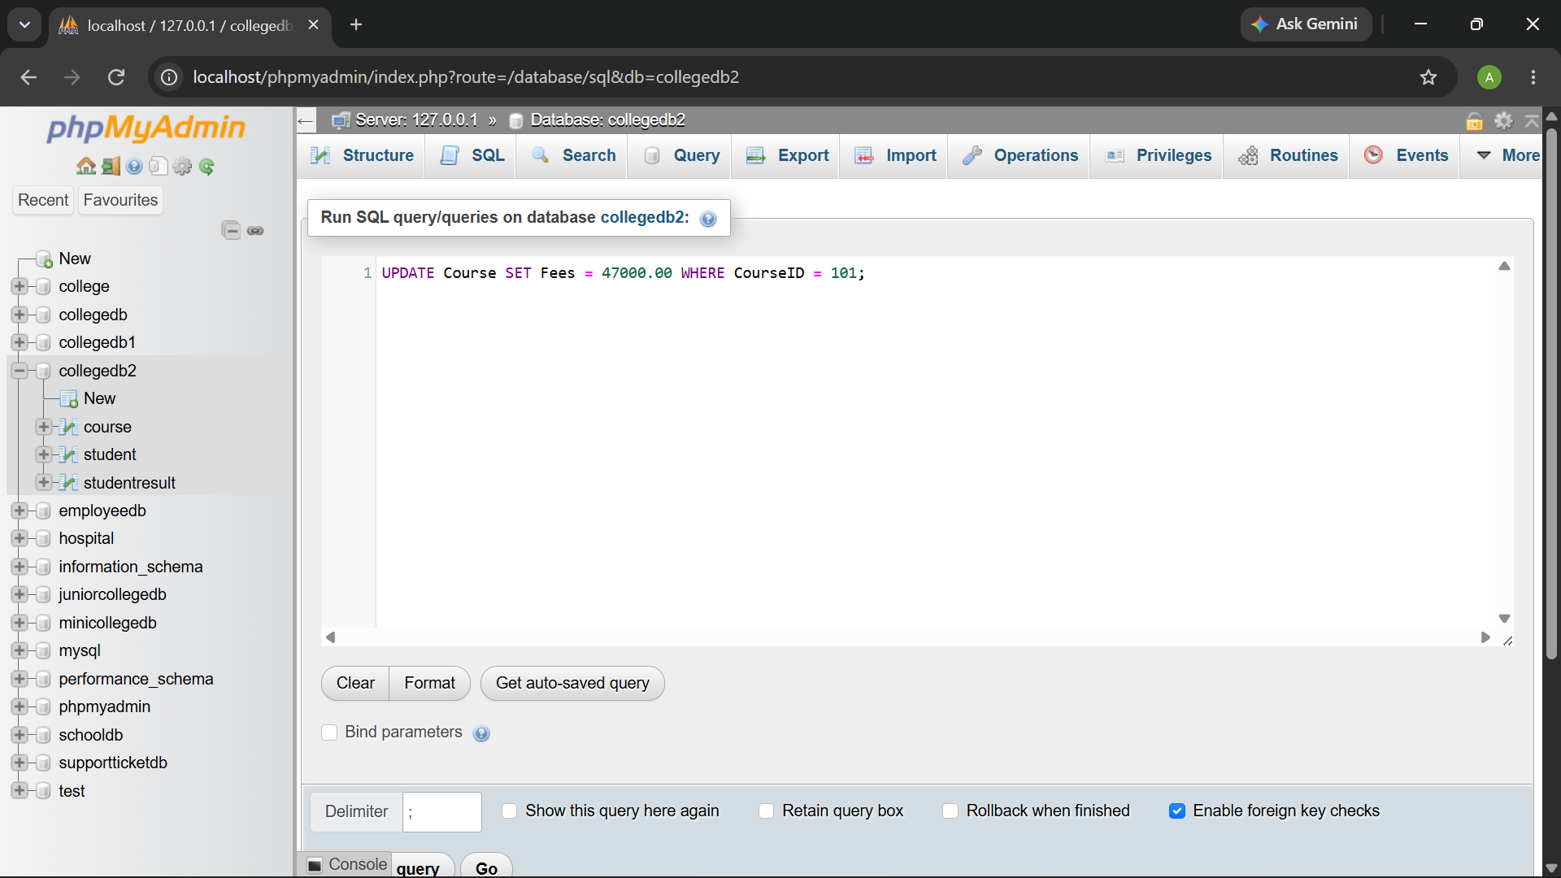
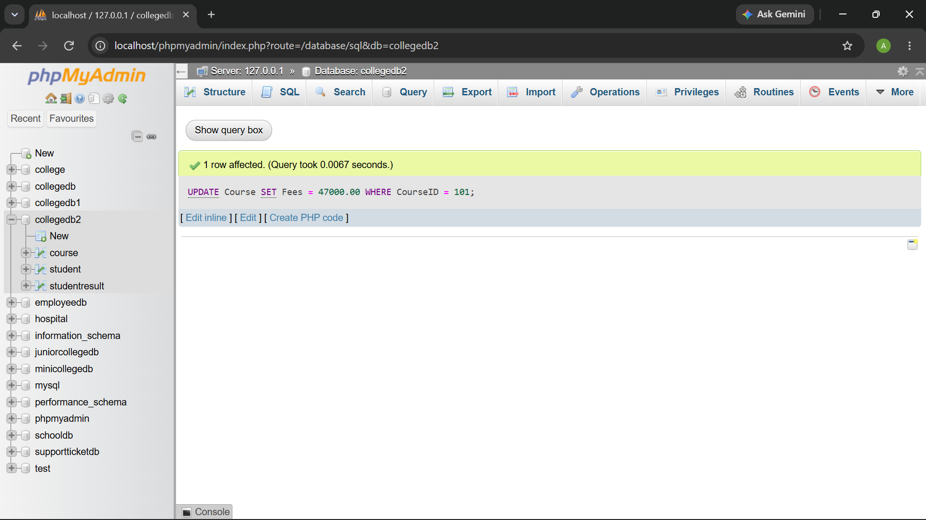

Q6) Write a MySQL query to delete one student record using StudentID.
Query: DELETE FROM Student WHERE StudentID = 6;
Output:
